West Coast Communities Transportation Meeting

Wednesday, September 30th

Tofino Council Chambers

1:00 pm – 3:00 pm

Present:
Aaron Rodgers, District of Tofino; Don Buchner, Wheels for Wellness; Jen Dart, Tofino Chambers of Commerce; Jon Towgood, District of Ucluelet; Juliet Van Vliet, Coastal Family Resource Coalition; Marilyn McEwan, District of Ucluelet; Trevor Wickham, Ucluelet First Nation; Rebecca Hurwitz, Clayoquot Biosphere Trust; Marcie DeWitt, Alberni Clayoquot Health Network

Regrets:
Tony Bennet, Alberni Clayoquot Regional District; Cliff Atleo, Ahousaht First Nation; Dylan Greene, Tofino Bus; Evan Hauser, Nuu-chah-nulth Employment and Training Program

Welcome
Marcie acknowledged the meeting was taking place on traditional Tla-o-qui-aht First Nation territory and thanked participants for making the time to attend. A round table of introductions was conducted and each participant was asked to speak to their goals and priorities for attending the meeting.
Goals

District of Ucluelet
- Wheels for Wellness opportunities
- Access to health care
- Age friendly plan – opportunities
Chamber of Commerce
- Health of the community is important for business
- Transportation is a barrier to employment
- Eager to contribute to solutions
District of Tofino
- Drive forward action to address priorities
Clayoquot Biosphere Trust
- Address youth safety concerns and increase connection/participation in community
- Data collection opportunities and partnerships through vital signs and living wage reports
- Investigate tools to assist
Coastal Family Resource Coalition
- Coming Together Forum identified transportation as a key priority for community health
- Child and Youth working group has identified as a top priority for youth
- Excited to support and maintain the conversation
Ucluelet First Nation
- Isolated community
- Bring as many services into community but require increased access

ACHN Commitment
Marcie took the opportunity to define the role which the ACHN has committed to take for transportation initiatives:
- Convene and communicate – bring in partners, gather information and pull together working groups when no other group has the mandate to do so.
Lead a regional action table to influence regional initiatives.
- Identify opportunities – assist in regional conversations to bring forward opportunities, leverage influence, resources, information and stakeholders.
- Monitor and evaluate – ensure momentum is maintained, evaluate impact and progress, utilize information to inform future initiatives and regional stakeholders

Review opportunities

Wheels for Wellness
Don Buchner, ED for Wheels for Wellness, provided an overview of plans for medical service to west coast communities and provided a copy of the Annex A submitted in an RFP to Island Health for medical services travel which includes west coast communities.
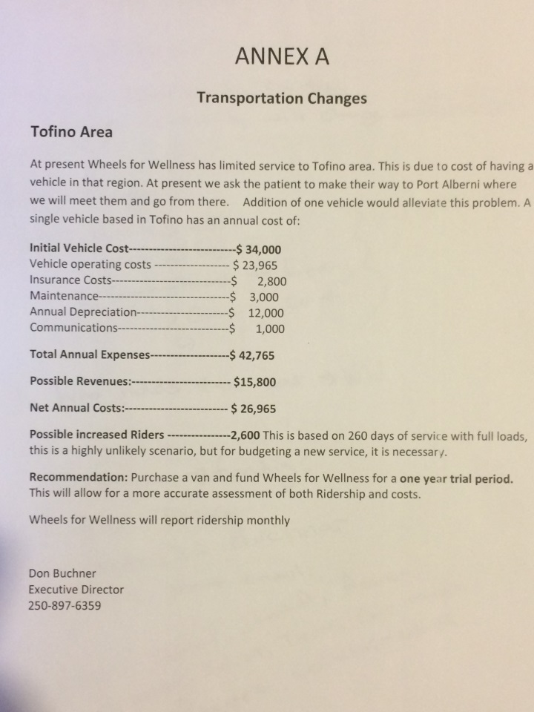

Wheels for Wellness is prepared to move forward with a pilot project to provide services to the west coast communities whether successful in this RFP or not, after a pilot the program could be maintinaed through gaming grant funds.
Program would provide:
- Transportation for confirmed medical appointments over 60 kms from pick up.
- Trip coordination from Wheels for Wellness call centre
- Wheels for Wellness van and maintenance
- Marketing and promotion of service
West Coast region contributions:
- Volunteer drivers with appropriate commercial driving certifications
- Funding commitment, approx. $25,000 which could be split between stakeholders to increase feasibility ($5000/per community/stakeholder group)

Action Items:
- Aaron Rodgers to convene a working group meeting next week (October 5th to 9th) for action planning around this opportunity
- Don Buchner to provide details of community commitments and requirements in both possible scenarios (Successful RFP vs Pilot Project)
- Working Group to formalize plan, budget and timeline, reach out to identified stakeholders
- Working group members – Juliet Van Vliet, Aaron Rodgers, Marilyn McEwan, Jon Towgood, Trevor Wickham

Additional Partners Identified
- Communities not present for discussion (Tla-o-qui-aht, Ahousaht, Hesquiaht)
- First Nations Health Authority
- Division of Family Practice
- Tofino General Hospital/Rural Health Manager

ACHN Transportation Overview
Marcie touched quickly on information gathered through the ACHN Transportation initiative and action items moving forward. From the June 11th Dialog to Action the ACHN received input into the overall framework and scope of their role in transportation planning. Access to services and basic needs is the core priority for ACHN transportation planning. The ACHN will convene, communicate, support planning and action as well as monitor and evaluate transportation initiatives which align with identified priorities and ways forward.
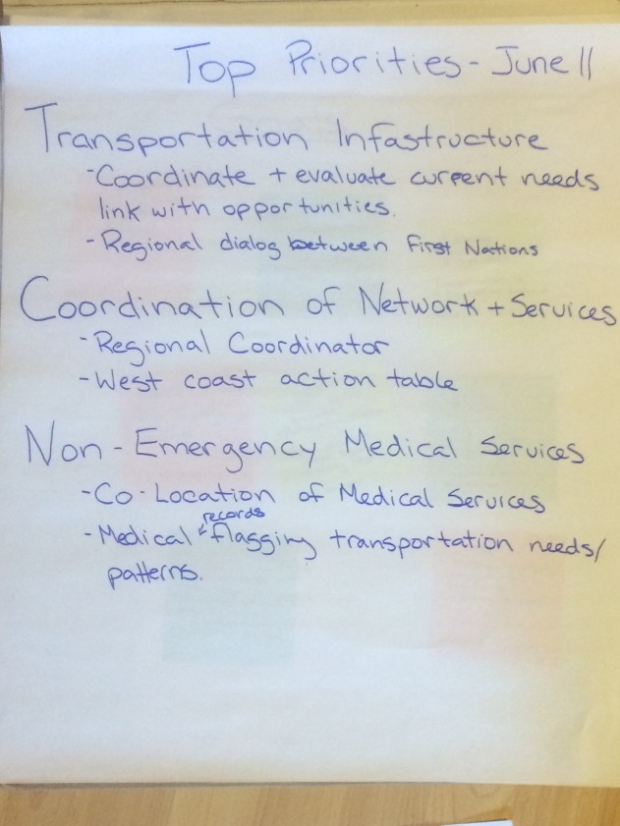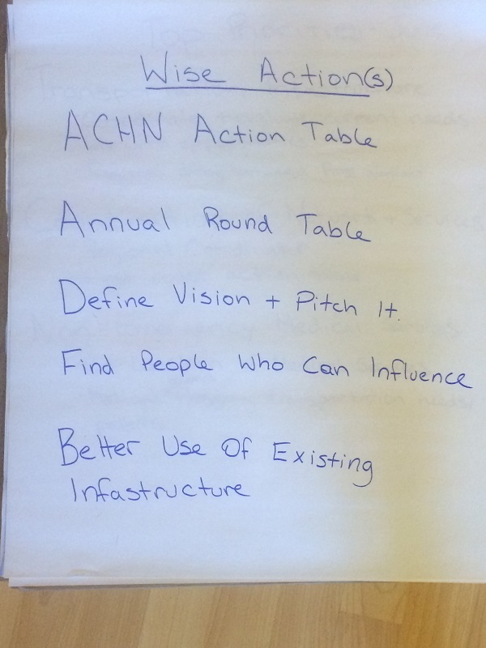

West Coast Priorities
The group engaged in a discussion around west coast priorities and opportunities. Transportation between communities was identified as the most evident first step forward in beginning to address west coast transportation needs. The group identified target populations and community needs, opportunities and models, additional needs and outlined a brief action plan to move forward action planning.

Priorities
- Increase transportation network between communities
- Increase access to employment, community services and opportunities for participation within regional communities
- Target youth, seniors, medical and employment access

Opportunities
- Medical travel out of town under investigation through Wheels for Wellness working group
- Within west coast communities
- Shuttle
- Ride share programs
- Hitch Planet model
- Centralized coordination website/data base – hack-a-thon to develop(?), also consider no/low tech options
- Provide free transportation for youth and seniors and low cost/subsidized transport between communities for employment

Needs
- Data
- Ridership from pilots
- Medical travel data (ACHN will have some preliminary numbers for mid-October)
- Shuttle data
- Transportation Habits Study – referenced by Juliet
- CBT transportation and youth data
- Inventory of existing infrastructure
- One pager – benefits of local transportation to employment, keeping young people and seniors in community, community development (infrastructure and social), community to community linkages (relationships)

Additional Partners
- Resort Collaborative
- West coast communities not represented at meeting
- Tofino Bus
- Parks Canada
- NETP

Action Items
- Aaron to request to Tofino Bus to provide a cost breakdown for annual service – 3 to 4 trips daily between communities
- Pilot project working group to be convened through ACHN when cost breakdown is prepared
- Share information on rideshare and hitch planet models
- Working group to identify and develop communications for features, cost and phases
- CBT to cumulate transportation data
- District of Ucluelet to bring forward Age Friendly report recommendations and opportunities
- Engage additional partners and investigate cost sharing

Meeting Close
Meeting was wrapped up at 3:00pm, action items and next steps were reviewed.
Next meeting will be convened by Aaron Rodgers, targeted to Wheels for Wellness planning.
Late fall meeting will follow to discuss ground transportation between communities upon completion of Tofino Bus cost breakdown.

