Table of Partners Minutes
Wednesday, May 20, 2020 @ 9:30 am
Via Zoom on-line meeting

Participants: Penny Cote (Chairperson), Marcie DeWitt (Coordinator), Josie Osborne (left meeting at 10:00), Patti Edwards, Anna Lewis, Lynne MacFadgen, Margaret Morrison joined at 10:15), Julia Martin

- CALL TO ORDER
The Coordinator called the meeting to order at 9:39 am.

The Coordinator acknowledged the territories we are all currently on.

- APPROVAL OF AGENDA & MINUTES
The Agenda for the May 20, 2020 was reviewed.
The Meeting Minutes of the April 15, 2020 meeting were reviewed.

- ACHN REPORTS
  - Coordinator Update & Island Health Reporting - reviewed the monthly reporting spreadsheet. Marcie DeWitt reported on activities that she was involved in since our previous meeting including:
- being busy with communications, lots of access and information for Facebook;
- supporting other networks;
- Port Alberni Housing Needs;
- sitting on the EOC leadership team;
- submitted a grant application and were successful for Poverty Reduction funding;
- report on vulnerable populations for the EOC;
- West Coast BC Transit;
- Completing quarterly reporting for Island Health as well as the annual report for Island Health.

- ACHN UPDATES
  - ACHN Coordinator Contract – forwarded to next meeting agenda

  - Moving Forward –

Josie Osborne:
- Tofino has implemented two COVID 19 recovery task forces – one economic based and one community health based; hoping to expand to regional focus
- Identified a gap with seniors and the need for effort to keep seniors healthy and at home, as there are no long-term care facilities on the west coast.
- Another topic is support for youth while not physically in school / summer camps are questionable too.
- Opportunities to bridge between AV & WC.

Anna Lewis:
- Grow Local events have been very successful
- Farmer’s markets are seeing huge sales and community support
- Awaiting provincial reply regarding Class D & E designation for slaughtering animals
- Air Quality – ACRD undergoing online public consultation for 2 bylaws focusing on air quality: one regarding aging woodstoves and one regarding outdoor burning

Penny Cote:
- ACRD working on recovery planning and have struck a select committee for this purpose

Lynne MacFadgen:
- Getting creative with digital delivery
- Challenged with remote access and bandwidth
- Modifying the hands-on required portions of learning
- June 1st, Market Gardener Program is starting
- In partnership with Port Alberni Shelter Society for plots of land
- Food hub developments with PAPA: retro-fit fish plant as a food processing hub at the end of June

Patty Edwards:
- Lots of calls regarding benefits
- Anticipate the Premier will announce the legislature will begin sitting again in June

Margaret Morrison:
- Getting resourceful to find ways to continue to offer services
- Supporting the senior’s loner iPad program

- JOINED BY THE CFRC
Members of the CFRC logged on and joined the ACHN meeting at 10:00.
Another Mural was created and documented by the CFRC including:
Intros/ Updates/ Priorities
Lessons Learned
What is working?
What has not worked?
What are the gaps?
Wish List – meeting ran out of time – please email Marcie or Brett with your wish list items to be included on the Mural:
Actionable takeaways
Three wishes
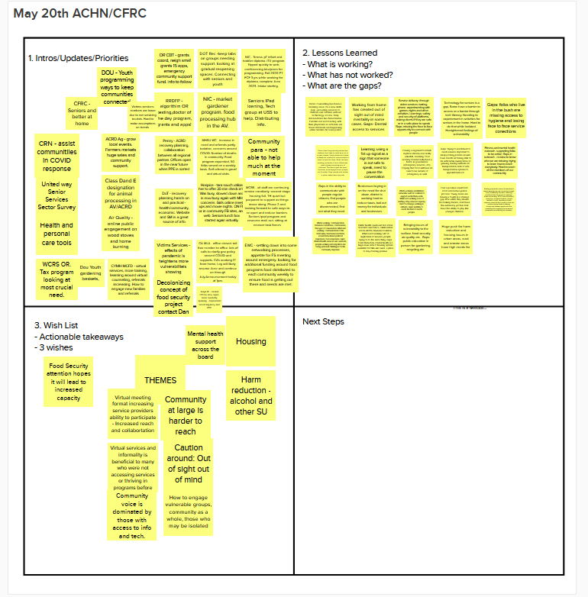

- MEETING ADJORNED

The meeting adjourned at 12:01pm. The next meeting of the Table of Partners will be held Wednesday, June 17, 2020 at 9:30 am.

